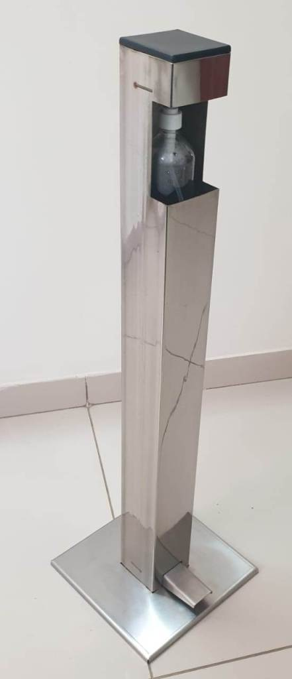

**Specifications**

Material : 304 Brushed S.S.

Height : 1Mtr

Colum size : 100x100

Base : 300 x300

Unit Weight: 8.5 Kg

Bottle Size : 3 ½” Dia

Use Any Bottle up to 1.5Ltr to 2 Ltr

------------------------------------------------------------------------------------------------------------------------------------------------------------