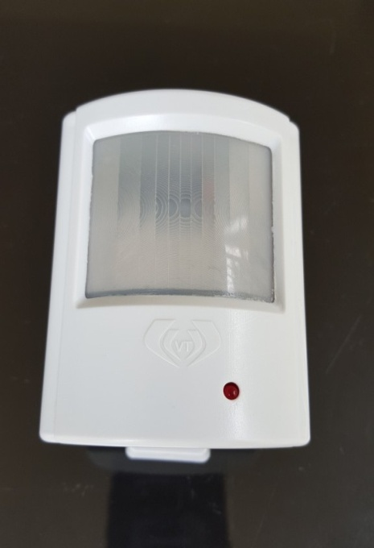

**CONNECTION DRAWING**

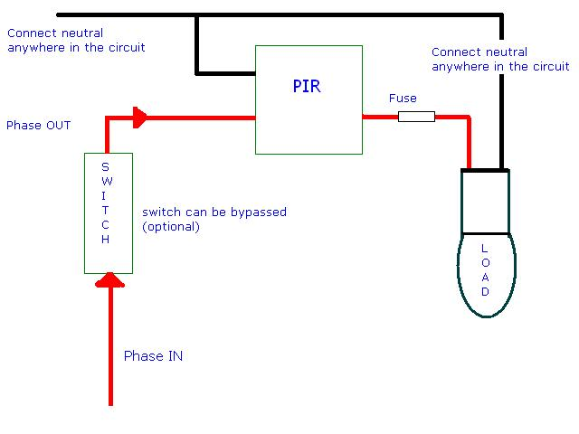

**Wire connections of power saver light switch: model: PSS – 900 W**

* **Brown wire is LINE**
* **Blue wires are NEUTRAL**
* **Red fuse wire is LOAD** 
  1. **Twisted pair of Brown & Blue wires to be connected to line & neutral (Brown is line & Blue is neutral) INPUT.**
  2. **The pair of Red fuse wire & Blue wires to be connected load & neutral (fuse wire is load & Blue is neutral) as OUTPUT.**

**NOTE: The pair of Red fuse wire & Blue can be directly connected to load (bulb).**

**(Automatic light)** INSTRUCTIONS OF USE

**The product is a new energy saving switch with a good sensitivity detector circuit. When humans enter the detection field, it will start the load at once. It identifies automatically day and night. Its Installation is very convenient and its usage is very wide. Besides bathrooms it can be installed in corridors, stair cases basements, Garages, etc,**

**SPECIFICATIONS:**

**Power source : 110-220 V AC**

**Rated load : 900 W**

**Detection Angle : 140 deg**

**Power frequency : 50 – 60 Hz**

**Ambient light (adjustable) : < 2 Lux – daylight**

**Detection Distance : 10m max (<24 deg c)**

**Time-Delay ( adjustable) : Min 8 sec to Max 5 min**

**Working temperature : .20 - 40 deg c**

**Working Humidity : < 93%RH**

**Power consumption : Max 45mW Static**

**Detection motion speed : 0.6 – 1.5 m/s**

**Installation height : 1.5 m – 3.5m**

**Size : L 80mm x W 62mm x TH 38mm**

**Features:**

* **Long Sensing Distance over 10 Meters.**
* **Viewing Angle over 140deg.**
* **Can handle up to 1.3kw load directly.**
* **Light Sensor included & can be set for deferent Lux levels to switch ON/OFF with motion.**
* **Inbuilt timer up to 45 minutes.**

**Optional to suit occupancy requirements.**

* **Works on 220V AC.**
* **Universal mounting bracket to set better viewing angles.**
* **Fuse provided to safe guard the product in case of short circuit.**
* **Device protected from spikes & lightening suitable for corridors, staircase, porticos, etc,.**

**FUNCTION:**

**Detection field is made up of up and down & left and right Service field. It has the relationship between movement and sensitivity.**

* **Can identify day and night: The user can adjust ambient light when it is connected. It can work in day and night when it is in anti clockwise position (max). It can work only in the night when it is in the clockwise position (min).**
* **Time-Delay added continuously: when it receives the second induction signal after the first time delay is completed, the load will be automatically switch on into the time delay again.**
* **Time- Delay adjustment: it can be set from Minimum 8 s to Max is 6 min.**

**INSTALLATION:**

**Switch off the power.**

* **Connect the power cable (According the symbol of <L> and <N>)**
* **Connect the load cable.**
* **Fix the mounting bracket and align the sensor body .**
* **Switch on the power, so you can test it.**
* **Wait for 30 sec for unit to stabilize.**

**CONNECTION- TEST:**

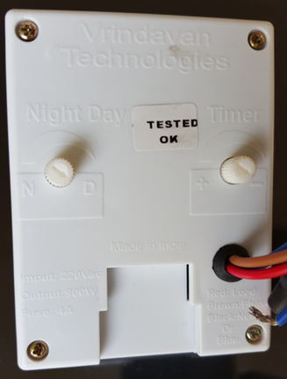

**The light-control knob (1) turn clockwise for the maximum (day).**

* **the time-control knob (2) turn clockwise for the maximum(adjustable) 6 min.**
* **When you switch on the power, the load will work. Under the no signals**

**conditions, the load should stop working within 5- 30 s the 1st time.**

* **The unit is now active .Any intrusion will activate the load and will switch off after the time lapse set ,up to a maximum of 6 minutes. If the intruder continues to stay in the sensing area ,the time lapse gets added till he leaves the sensing area.**

**NOTE:**

**Installation to be done by a experienced electrician**

**There should be no objects in the line of detection.**

**Please do not open the case for your safety if you find any hitch after installation.**

**PROBLEM AND SOLUTIONS:**

**The load does not work:**

**a. check the power and the load.**

**b. If the load is OK, please check if the ambient light corresponds to the**

**day/nightsetting.**

**The sensitivity is poor:**

**a. please check if there is any hindrance in front of the detection zone.**

**b. please check the ambient light setting.**

**c. please check the if the signals source is in the detection field.**

**d. please check the installation height.**

**The sensor can not shut off the load automatically.**

**a. If there is continuous signal in the detection field.**

**b. If the time delay is maximum.**

**c. If the air temperature changes near the sensor, for eg: air condition or central**

**heating etc.**

**e. There should be no objects in the line of detection.**

**Packing:**

**Inner Packing: 1pcs/box**

**Outer Packing: 20pcs /carton**