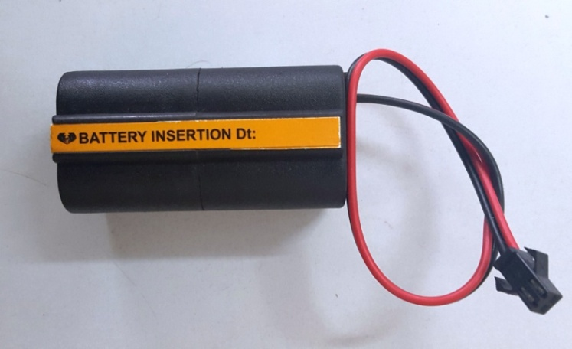

**Battery Container ( ‘AA’)**

**Power supply: DC 6v (4x1.5v Alkaline Batteries)**

**Materials – FR Engineering Plastic**

**We can Supply with different connectors**