**V**rindavan Technologies

E-mail : info@vrindavantechnologies.com

Tel:+91-80-41266977,080-41201590

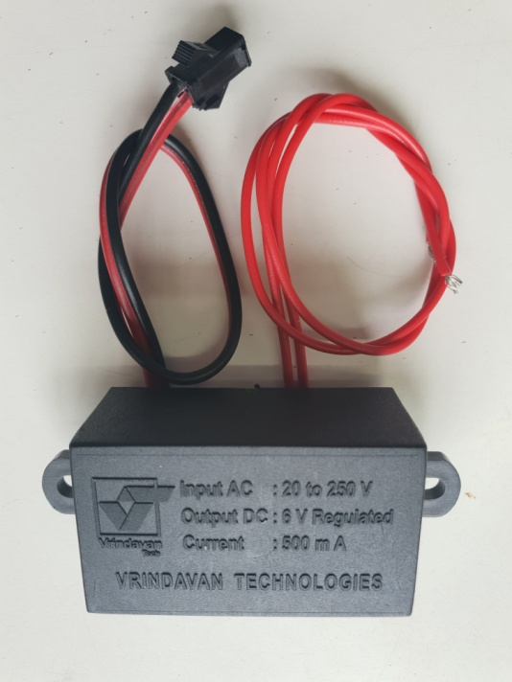

Ac Adapter

Input AC: 20 to 250V

Output: 6V DC Regulated

Current: 500mA

Epoxy Molded

Working Humidity: <95% RH

Low Ripple Noise

Inline EMI/RFI Filter

We can Supply with different connectors